UNIT -3(OOPS)
Inheritance
The capability of a class to derive properties and characteristics from another class is called Inheritance. Inheritance is one of the most important features of Object Oriented Programming in C++.In C++, inheritance is a process in which one object acquires all the properties and behaviors of its parent object automatically. In such way, you can reuse, extend or modify the attributes and behaviors which are defined in other class.
In C++, the class which inherits the members of another class is called derived class and the class whose members are inherited is called base class. The derived class is the specialized class for the base class.
Code reusability: Now you can reuse the members of your parent class. So, there is no need to define the member again. So less code is required in the class.
- class: keyword to create a new class
- derived_class_name: name of the new class, which will inherit the base class
- access-specifier: Specifies the access mode which can be either of private, public or protected. If neither is specified, private is taken as default.
- base-class-name: name of the base class.

Example
// C++ program to demonstrate inheritance

#include <iostream>
using namespace std;

// base class
class Animal {

public:
void eat() {
cout << "I can eat!" << endl;
}

void sleep() {
cout << "I can sleep!" << endl;
}
};

// derived class
class Dog : public Animal {

public:
void bark() {
cout << "I can bark! Woof woof!!" << endl;
}
};

int main() {
// Create object of the Dog class
Dog dog1;

// Calling members of the base class
dog1.eat();
dog1.sleep();

// Calling member of the derived class
dog1.bark();

return 0;
}

Modes of Inheritance in C++
Mode of inheritance controls the access level of the inherited members of the base class in the derived class. In C++, there are 3 modes of inheritance:

- Public Mode
- Protected Mode
- Private Mode

Public Inheritance Mode
If we derive a subclass from a public base class. Then the public member of the base class will become public in the derived class and protected members of the base class will become protected in the derived class.

Protected Inheritance Mode
If we derive a subclass from a Protected base class. Then both public members and protected members of the base class will become protected in the derived class.

Private Inheritance Mode
If we derive a subclass from a Private base class. Then both public members and protected members of the base class will become private in the derived class. They can only be accessed by the member functions of the derived class.
Private mode is the default mode that is applied when we don’t specify any mode

Types Of Inheritance
- Single inheritance
- Multiple inheritance
- Hierarchical inheritance
- Multilevel inheritance
- Hybrid inheritance
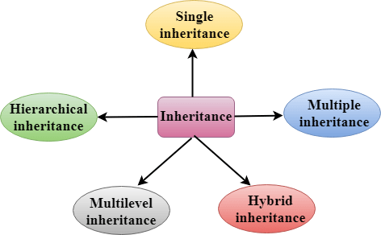

1. Single Inheritance
Single inheritance is defined as the inheritance in which a derived class is inherited from the only one base class.

Where 'A' is the base class, and 'B' is the derived class.
When one class inherits another class, it is known as single level inheritance

#include <iostream>
using namespace std;
class Account {
public:
float salary = 60000;
};
class Programmer: public Account {
public:
float bonus = 5000;
};
int main(void) {
Programmer p1;
cout<<"Salary: "<<p1.salary<<endl;
cout<<"Bonus: "<<p1.bonus<<endl;
return 0;
}

2. Multilevel Inheritance
Multilevel inheritance is a process of deriving a class from another derived class.


When one class inherits another class which is further inherited by another class, it is known as multi level inheritance in C++. Inheritance is transitive so the last derived class acquires all the members of all its base classes.
Example of multi level inheritance in C++.
#include <iostream>
using namespace std;
class Animal {
public:
void eat() {
cout<<"Eating..."<<endl;
}
};
class Dog: public Animal
{
public:
void bark(){
cout<<"Barking..."<<endl;
}
};
class BabyDog: public Dog
{
public:
void weep() {
cout<<"Weeping...";
}
};
int main(void) {
BabyDog d1;
d1.eat();
d1.bark();
d1.weep();
return 0;
}

3. Multiple Inheritance
Multiple inheritance is the process of deriving a new class that inherits the attributes from two or more classes.
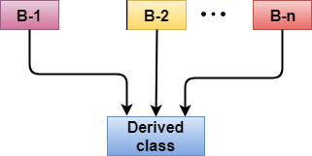
#include <iostream>
using namespace std;
class A
{
protected:
int a;
public:
void get_a(int n)
{
a = n;
}
};

class B
{
protected:
int b;
public:
void get_b(int n)
{
b = n;
}
};
class C : public A,public B
{
public:
void display()
{
std::cout << "The value of a is : " <<a<< std::endl;
std::cout << "The value of b is : " <<b<< std::endl;
cout<<"Addition of a and b is : "<<a+b;
}
};
int main()
{
C c;
c.get_a(10);
c.get_b(20);
c.display();

return 0;
}

4. Hierarchical Inheritance
Hierarchical inheritance is defined as the process of deriving more than one class from a base class.
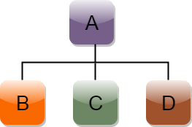
// C++ program to demonstrate hierarchical inheritance

#include <iostream>
using namespace std;

// base class
class Animal {
public:
void info() {
cout << "I am an animal." << endl;
}
};
class Dog : public Animal {
public:
void bark() {
cout << "I am a Dog. Woof woof." << endl;
}
};
class Cat : public Animal {
public:
void meow() {
cout << "I am a Cat. Meow." << endl;
}
};
int main() {
// create object of Dog class
Dog dog1;
cout << "Dog Class:" << endl;
dog1.info(); // parent Class function
dog1.bark();
Cat cat1;
cout << "\nCat Class:" << endl;
cat1.info(); // parent Class function
cat1.meow();

return 0;
}

5. C++ Hybrid Inheritance
Hybrid inheritance is a combination of more than one type of inheritance.
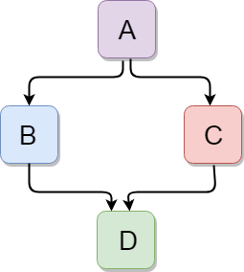

#include <iostream>
using namespace std;
class A
{
protected:
int a;
public:
void get_a()
{
std::cout << "Enter the value of 'a' : " << std::endl;
cin>>a;
}
};

class B : public A
{
protected:
int b;
public:
void get_b()
{
std::cout << "Enter the value of 'b' : " << std::endl;
cin>>b;
}
};
class C
{
protected:
int c;
public:
void get_c()
{
std::cout << "Enter the value of c is : " << std::endl;
cin>>c;
}
};

class D : public B, public C
{
protected:
int d;
public:
void mul()
{
get_a();
get_b();
get_c();
std::cout << "Multiplication of a,b,c is : " <<a*b*c<< std::endl;
}
};
int main()
{
D d;
d.mul();
return 0;
}

Virtual base class

Virtual base classes are used in virtual inheritance in a way of preventing multiple “instances” of a given class appearing in an inheritance hierarchy when using multiple inheritances.
Need for Virtual Base Classes: Consider the situation where we have one class A . This class A is inherited by two other classes B and C. Both these class are inherited into another in a new class D
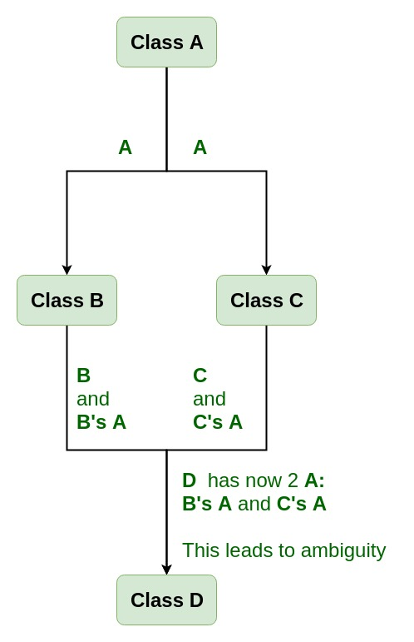

Data members/function of class A are inherited twice to class D. One through class B and second through class C. When any data / function member of class A is accessed by an object of class D, ambiguity arises as to which data/function member would be called? One inherited through B or the other inherited through C. This confuses compiler and it displays error. The C++ Course covers this topic thoroughly, ensuring you grasp how to implement virtual inheritance correctly in your applications.

Base classes are the classes from which other classes are derived. The derived(child) classes have access to the variables and methods/functions of a base(parent) class. The entire structure is known as the inheritance hierarchy.

EXAMPLE 1

#include <iostream>
using namespace std;

class A {
public:
int a;
A() // constructor
{
a = 10;
}
};

class B : public virtual A {
};

class C : public virtual A {
};

class D : public B, public C {
};

int main()
{
D object; // object creation of class d
cout << "a = " << object.a << endl;

return 0;
}

EXAMPLE 2

#include <iostream>
using namespace std;

class A {
public:
void show()
{
cout << "Hello from A \n";
}
};

class B : public virtual A {
};

class C : public virtual A {
};

class D : public B, public C {
};

int main()
{
D object;
object.show();
}

Operator Overloading
Operator overloading is a compile-time polymorphism. It is an idea of giving special meaning to an existing operator in C++ without changing its original meaning.
C++ has the ability to provide the operators with a special meaning for a data type, this ability is known as operator overloading. Operator overloading is a compile-time polymorphism. For example, we can overload an operator ‘+’ in a class like String so that we can concatenate two strings by just using +. Other example classes where arithmetic operators may be overloaded are Complex Numbers, Fractional Numbers, Big integers, etc.

// C++ Program to Demonstrate
// Operator Overloading
#include <iostream>
using namespace std;

class Complex {
private:
int real, imag;

public:
Complex(int r = 0, int i = 0)
{
real = r;
imag = i;
}

// This is automatically called when '+' is used with
// between two Complex objects
Complex operator+(Complex const& obj)
{
Complex res;
res.real = real + obj.real;
res.imag = imag + obj.imag;
return res;
}
void print() { cout << real << " + i" << imag << '\n'; }
};

int main()
{
Complex c1(10, 5), c2(2, 4);
Complex c3 = c1 + c2;
c3.print();
}

Function Overriding

A function is a block of statements that together performs a specific task by taking some input and producing a particular output. Function overriding in C++ is termed as the redefinition of base class function in its derived class with the same signature i.e. return type and parameters. It can be of both type: Compile Time and Runtime Polymorphism.4
Function overriding is a type of polymorphism in which we redefine the member function of a class which it inherited from its base class. The function signature remains same but the working of the function is altered to meet the needs of the derived class. So, when we call the function using its name for the parent object, the parent class function is executed. But when we call the function using the child object, the child class version will be executed.
If derived class defines same function as defined in its base class, it is known as function overriding in C++. It is used to achieve runtime polymorphism. It enables you to provide specific implementation of the function which is already provided by its base class.
#include <iostream>
using namespace std;

class Animal {
public:
virtual void makeSound() {
cout << "Animal makes a sound" << endl;
}
};

class Dog : public Animal {
public:
void makeSound() override {
cout << "Dog barks" << endl;
}
};

int main() {
Animal* animal = new Dog(); // Upcasting
animal->makeSound(); // Output: Dog barks
delete animal;
return 0;
}

Pure Virtual Functions and Abstract Classes
Sometimes implementation of all functions cannot be provided in a base class because we don’t know the implementation. Such a class is called an abstract class
A pure virtual function (or abstract function) in C++ is a virtual function for which we can have an implementation, But we must override that function in the derived class, otherwise, the derived class will also become an abstract class. A pure virtual function is declared by assigning 0 in the declaration.
By definition, a C++ abstract class must include at least one pure virtual function. Alternatively, put a function without a definition. Because the subclass would otherwise turn into an abstract class in and of itself, the abstract class's descendants must specify the pure virtual function.
Broad notions are expressed using abstract classes, which can then be utilized to construct more specific classes. You cannot make an object of the abstract class type. However, pointers and references can be used to abstract class types. When developing an abstract class, define at least one pure virtual feature. A virtual function is declared using the pure specifier (= 0) syntax.
#include <iostream>
using namespace std;
class Base {
int x;
public:
// pure virtual function
virtual void fun() = 0;
int getX() { return x; }
};
class Derived : public Base {
// private member variable
int y;
public:
void fun() { cout << "fun() called"; }
};
int main(void)
{
Derived d;
d.fun();
return 0;
}

Difference between virtual and pure virtual

Virtual function | Pure virtual function
A virtual function is a member function of base class which can be redefined by derived class. | A pure virtual function is a member function of base class whose only declaration is provided in base class and should be defined in derived class otherwise derived class also becomes abstract.
Classes having virtual functions are not abstract. | Base class containing pure virtual function becomes abstract.

Difference between overloading and overriding

Method Overloading | Method Overriding
Method overloading is a compile-time polymorphism. | Method overriding is a run-time polymorphism.
Method overloading helps to increase the readability of the program. | Method overriding is used to grant the specific implementation of the method which is already provided by its parent class or superclass.
It occurs within the class. | It is performed in two classes with inheritance relationships.
Method overloading may or may not require inheritance. | Method overriding always needs inheritance.
In method overloading, methods must have the same name and different signatures. | In method overriding, methods must have the same name and same signature.
In method overloading, the return type can or can not be the same, but we just have to change the parameter. | In method overriding, the return type must be the same or co-variant.
Static binding is being used for overloaded methods. | Dynamic binding is being used for overriding methods.
Private and final methods can be overloaded. | Private and final methods can’t be overridden.
The argument list should be different while doing method overloading. | The argument list should be the same in method overriding.

